Data Mining Lab
EXP-1:Use the K-means Algorithm to Cluster A Data Set into 3, 5, and 7 Clusters. Which one is the best cluster and why? Use Agglomerative and Divisive clustering algorithm to partition the below clustering data into 4- clusters.

- #pip install scikit-learn
- import math
- import random
- import numpy as np
- from sklearn.metrics import silhouette_score

- # -------- INPUT --------
- n = int(input("Enter number of points: "))
- data = []

- print("Enter points (x y):")
- for _ in range(n):
- x, y = map(float, input().split())
- data.append([x, y])

- # -------- DISTANCE --------
- def dist(p1, p2):
- return math.sqrt((p1[0]-p2[0])**2 + (p1[1]-p2[1])**2)

- # -------- K-MEANS --------
- def kmeans(data, k):
- centroids = random.sample(data, k)

- while True:
- clusters = [[] for _ in range(k)]

- for p in data:
- d = [dist(p, c) for c in centroids]
- idx = d.index(min(d))
- clusters[idx].append(p)

- new_centroids = []
- for cluster in clusters:
- if cluster:
- x = sum(p[0] for p in cluster) / len(cluster)
- y = sum(p[1] for p in cluster) / len(cluster)
- new_centroids.append([x, y])
- else:
- new_centroids.append([0, 0])

- if new_centroids == centroids:
- break

- centroids = new_centroids

- return clusters

- # -------- K-MEANS FOR 3,5,7 --------
- print("\n--- K-MEANS RESULTS ---")

- best_k = None
- best_score = -1

- for k in [3, 5, 7]:
- print(f"\nK = {k}")
- clusters = kmeans(data, k)

- # print clusters
- for i, c in enumerate(clusters):
- print(f"Cluster {i+1}: {c}")

- # -------- CREATE LABELS FOR SILHOUETTE --------
- labels = []
- for i, cluster in enumerate(clusters):
- for _ in cluster:
- labels.append(i)

- # -------- SILHOUETTE SCORE --------
- if len(set(labels)) > 1:
- score = silhouette_score(np.array(data), labels)
- print(f"Silhouette Score = {score:.4f}")

- if score > best_score:
- best_score = score
- best_k = k
- else:
- print("Silhouette not defined")

- print(f"\nBest K = {best_k} (highest silhouette score)")

- # -------- AGGLOMERATIVE --------
- print("\n--- AGGLOMERATIVE (4 clusters) ---")

- clusters = [[p] for p in data]

- while len(clusters) > 4:
- min_d = float('inf')
- pair = (0, 1)

- for i in range(len(clusters)):
- for j in range(i+1, len(clusters)):
- d = dist(clusters[i][0], clusters[j][0])
- if d < min_d:
- min_d = d
- pair = (i, j)

- i, j = pair
- clusters[i] += clusters[j]
- clusters.pop(j)

- for i, c in enumerate(clusters):
- print(f"Cluster {i+1}: {c}")

- # -------- DIVISIVE --------
- print("\n--- DIVISIVE (4 clusters) ---")

- clusters = [data]

- while len(clusters) < 4:
- clusters.sort(key=len, reverse=True)
- largest = clusters.pop(0)

- split = kmeans(largest, 2)
- clusters.extend(split)

- for i, c in enumerate(clusters):
- print(f"Cluster {i+1}: {c}")

EXP-2: Frequent items set generation using the Apriori algorithm.
from itertools import combinations

# -------- Input --------
n = int(input("Enter number of transactions: "))
transactions = []

print("Enter items (space separated):")
for _ in range(n):
t = input().split()
transactions.append(set(t))

min_support = int(input("Enter minimum support: "))
min_confidence = float(input("Enter minimum confidence (0-1): "))

# -------- Support Function --------
def get_support(itemset):
count = 0
for t in transactions:
if itemset.issubset(t):
count += 1
return count

# -------- C1 --------
items = set()
for t in transactions:
items.update(t)

C1 = [{i} for i in items]

# -------- L1 --------
L = []
support_data = {}

L1 = []
for item in C1:
s = get_support(set(item))
if s >= min_support:
L1.append(set(item))
support_data[frozenset(item)] = s
print(f"{set(item)} -> {s}")

L.append(L1)

k = 2

# -------- Generate Lk --------
while L[k-2]:
print(f"\nGenerating L{k}...")

candidates = []
prev_L = L[k-2]

for i in range(len(prev_L)):
for j in range(i+1, len(prev_L)):
union = prev_L[i] | prev_L[j]
if len(union) == k:
candidates.append(union)

candidates = list(map(set, set(map(frozenset, candidates))))

Lk = []
for c in candidates:
s = get_support(c)
if s >= min_support:
Lk.append(c)
support_data[frozenset(c)] = s
print(f"{c} -> {s}")

if not Lk:
break

L.append(Lk)
k += 1

# -------- Final Frequent Itemsets --------
print("\nAll Frequent Itemsets:")
for i, level in enumerate(L, start=1):
print(f"L{i}: {level}")

# -------- Association Rules --------
print("\n--- Association Rules ---")

for itemset in support_data:
if len(itemset) < 2:
continue

for i in range(1, len(itemset)):
for antecedent in combinations(itemset, i):
antecedent = frozenset(antecedent)
consequent = itemset - antecedent

conf = support_data[itemset] / support_data[antecedent]

if conf >= min_confidence:
print(f"{set(antecedent)} -> {set(consequent)} (Confidence: {conf:.2f})")

EXP-3: Decision tree construction for classification (ID3 algorithm)
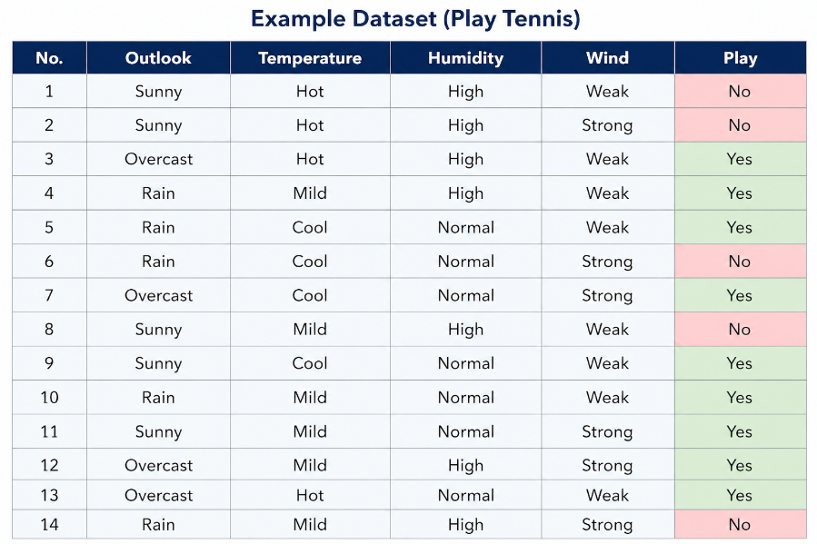

import math
import pandas as pd

# -------- DATASET --------
data = pd.DataFrame([
['Sunny', 'Hot', 'High', 'Weak', 'No'],
['Sunny', 'Hot', 'High', 'Strong', 'No'],
['Overcast', 'Hot', 'High', 'Weak', 'Yes'],
['Rain', 'Mild', 'High', 'Weak', 'Yes'],
['Rain', 'Cool', 'Normal', 'Weak', 'Yes'],
['Rain', 'Cool', 'Normal', 'Strong', 'No'],
['Overcast', 'Cool', 'Normal', 'Strong', 'Yes'],
['Sunny', 'Mild', 'High', 'Weak', 'No'],
['Sunny', 'Cool', 'Normal', 'Weak', 'Yes'],
['Rain', 'Mild', 'Normal', 'Weak', 'Yes'],
['Sunny', 'Mild', 'Normal', 'Strong', 'Yes'],
['Overcast', 'Mild', 'High', 'Strong', 'Yes'],
['Overcast', 'Hot', 'Normal', 'Weak', 'Yes'],
['Rain', 'Mild', 'High', 'Strong', 'No']
])

data.columns = ['Outlook', 'Temperature', 'Humidity', 'Wind', 'Play']
target_col = 'Play'

# -------- ENTROPY --------
def entropy(column):
values = column.value_counts()
total = len(column)
ent = 0

for v in values:
p = v / total
ent += -p * math.log2(p)

return ent

# -------- INFORMATION GAIN --------
def info_gain(data, feature, target):
total_entropy = entropy(data[target])
values = data[feature].unique()

weighted_entropy = 0
for v in values:
subset = data[data[feature] == v]
weighted_entropy += (len(subset)/len(data)) * entropy(subset[target])

return total_entropy - weighted_entropy

# -------- ID3 --------
def id3(data, features, target):
if len(data) == 0:
return None

if len(data[target].unique()) == 1:
return data[target].iloc[0]

if len(features) == 0:
return data[target].mode()[0]

gains = [info_gain(data, f, target) for f in features]
print("Gains:", dict(zip(features, [round(g,3) for g in gains])))

best_feature = features[gains.index(max(gains))]
tree = {best_feature: {}}

for value in data[best_feature].unique():
subset = data[data[best_feature] == value]
new_features = [f for f in features if f != best_feature]

subtree = id3(subset, new_features, target)
tree[best_feature][value] = subtree

return tree

# -------- RUN --------
features = list(data.columns)
features.remove(target_col)

tree = id3(data, features, target_col)

print("\n--- DECISION TREE ---")
print(tree)

